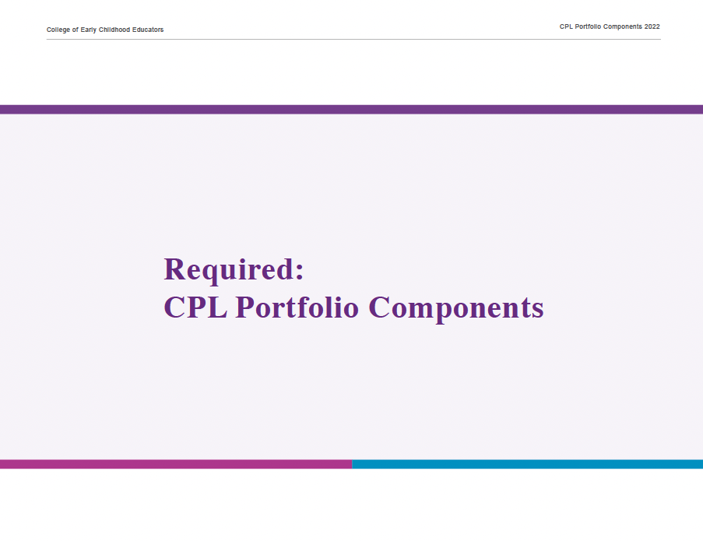

Name: Registration #: Date:

Reflection Planning Tool A. Self-Reflection and Discovery

- In planning your upcoming CPL portfolio year, consider and record your potential professional learning priorities, interests and needs.

For inspiration, consider some of the following:
“RECEs are reflective and intentional professionals who engage in ongoing learning. They engage in critical reflection, collaborative inquiry and demonstrate their commitment to ongoing learning by engaging in the Continuous Professional Learning program.” (Standard IV: A, C.1)
- your role and responsibilities daily practice
- experiences and opportunities
- challenges, concerns, or questions
- changes in the sector or in your work
- leadership development
- legislation, policy and research
- College advisories and guidelines

Insert your answer here

Name: Registration #: Date:

Reflection Planning Tool A. Self-Reflection and Discovery

- What feedback have you received about your professional knowledge and practice? Reflect on feedback from others (e.g., colleagues, supervisors, families, children) about your strengths and areas for growth.

Insert your answer here

- How do you learn best? Note the ways you like to learn. For example, reading, discussions, visuals, listening, experiential learning.

Some prompts for your reflection:
- Consider your past portfolio learning activities and reflections.
- What makes learning meaningful to you?
- How might you adapt your learning to co-construct knowledge with other RECEs and colleagues?

Insert your answer here

Name: Registration #: Date:

Reflection Planning Tool A. Self-Reflection and Discovery

- Based on your reflections above, identify one topic to prioritize for this year’s CPL Portfolio.

Some questions to guide your decision-making:
- How would focusing on this topic benefit your current or future practice?
- What’s your current knowledge and experience related to this topic?
- What outcome would you like as a result of additional learning in this area?
- Do you want to focus on enhancing knowledge, skills or experience?

Insert your answer here

Name: Registration #: Date:

Reflection Planning Tool B. Integrate the Code of Ethics and Standards of Practice

As a regulated professional, it’s important to regularly review the Code of Ethics and Standards of Practice. Identify the Standards of Practice that relate to the learning you want to prioritize for this year’s CPL Portfolio.

Standards of Practice
- Standard I: Caring and Responsive Relationships
- Standard II: Curriculum and Pedagogy
- Standard III: Safety, Health and Well-Being in the Learning Environment
- Standard IV: Professionalism and Leadership
- Standard V: Professional Boundaries, Dual Relationships and Conflicts of Interest
- Standard VI: Confidentiality, Release of Information and Duty to Report

Insert your answer here

Name: Registration #: Date:

Reflection Planning Tool C. Take Action: Learning Goal and Plan

Review your responses in sections A and B.

In the chart:
- Identify one professional learning goal based on the topic of learning that you prioritized above.
- Identify learning activities or experiences that will support you with meeting your goal.
- Indicate when you plan to engage in the learning activities or experiences during this portfolio year (optional).

Refer to the CPL Portfolio Handbook, for examples of learning activities and experiences (p. 11).

Professional Learning Goal | Insert your answer here

Professional learning activities and experiences  (e.g., case study or practice scenarios, review College resources, webinars, facilitated discussions with colleagues, etc.) | Timelines  (Optional)
Insert your answer here | Insert your answer here
Name: Registration #: Date:

Record of Professional Learning A. Engagement: Document Your Learning

As you complete your professional learning activities and experiences, record them in the Record of Professional Learning chart below. Keep all documentation (e.g., notes, reflections, samples of your work) with your portfolio.

Refer to the CPL Portfolio Handbook (p. 12) for examples of documentation.

Professional Learning Goal | Insert your answer here

Description of professional learning activities and experiences with dates | Documentation of professional learning  List the documentation that shows you have engaged in your learning activities and experiences. | Next steps  Consider some of the following questions:  - How will you integrate your learning into your professional practice?  - What are you inspired to learn next to build on your knowledge, skills and competencies?
Insert your answer here | Insert your answer here | Insert your answer here

Name: Registration #: Date:

Record of Professional Learning B. Expression: Reflect on Your Learning

Reflect on your professional learning during the past portfolio year. Generate your response in a format (e.g., writing, mind mapping, etc.) that works for you.

Some prompts to support your reflection:
- What were your accomplishments, challenges, or unexpected outcomes?
- What new insights did you discover about yourself or your practice?
- Did you share your learning with someone else (e.g., colleague, employer)? What was the outcome?
- How did your learning activities and experiences support you with working toward your goal?
- Are there areas where you would like to extend your learning after this portfolio cycle? If so, how might you do this?
- If you are not currently practising in the sector, how will your professional learning this past year support your readiness to practise?

Insert your answer here

